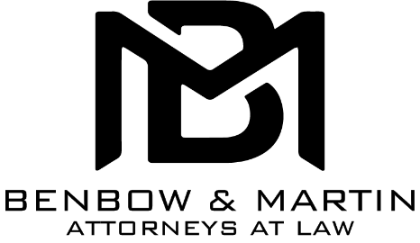
P.O. Drawer 432
Statesville, NC 28687-0432
C. David Benbow | david@statesvillelaw.com
Luke S. Martin | luke@statesvillelaw.com
Tyler J. Crawford | tyler@statesvillelaw.com

Monday, March 16, 2020

Dear Clients:
We here at Benbow & Martin want to continue serving you during the current pandemic. After careful consideration, we have decided to start conducting most of our consultations and appointments via phone or video conferencing. If you have an appointment that requires the signing of documents, i.e. Estate Planning: Will, Power of Attorney, Real Estate transactions, etc, we will still be conducting those in person. We will be taking extra steps in sanitizing our meeting areas to help reduce the spread of any illness.
The court system is following a specific protocol and you may “Like” and “Follow” Iredell County Clerk of Superior Court to help stay up to date with any changes.
If you have any questions regarding how you should proceed, please feel free to contact our main office at 704-871-9000.
Sincerely,
Our Firm

